Civil war in Rwanda

UNSC Resolution: | 1050
Date of adoption: | 8 March 1996
Operative paragraph: | 3
Demand number: | 1050.0311

Carla Winston

Wording of demand
Take all necessary steps to ensure that UNAMIR personnel, and equipment which is not remaining in Rwanda, can be withdrawn without impediment and in an orderly and safe manner

List of addressees of the demand
Government of Rwanda

Short-term compliance

Description of the addressee(s)’ conduct

5. Detailed plans for the withdrawal of the UNAMIR military personnel have been drawn up and are being implemented. As of 12 April 1996, a total of 679 personnel, comprising 11 military observers, 648 troops and 20 headquarters staff remained in Rwanda. It is expected that their withdrawal will be completed between 12 and 19 April (see annex).
7. On 25 March 1996, I submitted a report to the General Assembly on the disposition of UNAMIR assets (A/50/712/Add.2), in which I indicated that the estimated inventory value of the Mission’s assets as of 19 October 1995 amounted to approximately $62.5 million. I also stated in the report that non-lethal assets valued at approximately $9.2 million were earmarked for donation to the Government of Rwanda. In addition, assets considered beyond economic repair or removal, valued at approximately $6.1 million, would be made available to the Government, subject to the concurrence of the General Assembly.
8. The International Tribunal for Rwanda and the Government have reached an agreement on the rental of the Amahoro Hotel, the current UNAMIR headquarters, which is to be taken over by the Tribunal following the departure of UNAMIR. The Tribunal will take over responsibility for the operation and maintenance of the UNAMIR communications system and provide the communications needs of all other United Nations agencies in Rwanda that formerly relied on UNAMIR for this purpose.
17. In paragraph 2 of resolution 1050 (1996), the Security Council authorized elements of UNAMIR remaining in Rwanda prior to their final withdrawal to contribute, with the agreement of the Government of Rwanda, to the protection of the personnel and premises of the International Tribunal for Rwanda. Accordingly, following consultations, the Malawi infantry company of UNAMIR was retained at Kigali to assist in protecting the Tribunal until 8 April 1996.
30. As called for in paragraph 3 of resolution 1050 (1996), I trust that the Government of Rwanda will take the necessary measures to ensure that UNAMIR personnel and equipment can be withdrawn without impediment in an orderly and safe manner.
31. As the departure date of the last UNAMIR elements approaches, I wish to reiterate my warm appreciation to my Special Representative, Mr. Shaharyar Khan, and to all his dedicated staff who have carried out their task so ably under sometimes trying conditions.
(Report of the Secretary-General on the Implementation of Resolution 1050 (1996), UN Doc. S/1996/286 (15 April 1996), par. 5, 7-8, 17, 30-31)

5. As regards the functions of the Special Representative and his staff, these would, to a large extent, be determined by the wishes of the Government. On the basis of experience elsewhere, they could include the following: support and advice to the Government, as desired by it, on the political aspects of Rwanda’s current problems, especially in the fields of national reconciliation, the return of refugees and relations with its neighbours; provision of a direct channel of communication with the Secretary-General; advocacy for Rwanda vis-à-vis the United Nations system and the international community at large; and high-level coordination of all the activities of the United Nations system in Rwanda, not just the developmental and humanitarian activities that fall within the purview of the United Nations Resident Coordinator/Humanitarian Coordinator. The Office would also include the United Nations radio station, which would use personnel and equipment previously employed for Radio UNAMIR.
6. On 23 April, the Under-Secretary-General was informed by President Bizimungu that the Government had decided to confirm its acceptance of a United Nations Office on the basis described by him, but the Government was not willing to approve the proposed United Nations radio station; it would create the impression that UNAMIR was still in Rwanda under another guise and would involve a higher profile for the United Nations Office than the Government wished. However, the Government was ready to make available to the United Nations three hours of air time each evening on the Government’s radio station. The Under-Secretary-General expressed regret at the Government’s decision on the United Nations radio station but said that its alternative offer would be
carefully examined.
9. In addition to the above-reported discussions about the establishment of UNOR, the representatives of the Government raised with the Under-Secretary-General certain issues left pending following the withdrawal of UNAMIR, although they did not link them in any way to the question of the new Office.
10. Foremost among these was the former UNAMIR equipment which the United Nations had offered to the Government free of charge. The Under-Secretary- General explained, as had my Special Representative on previous occasions, that my ability to make such equipment available to the host Government was constrained by standing decisions of the General Assembly that gave priority to the requirements of present and future United Nations peace-keeping operations and to those of other United Nations bodies working in the country concerned. Although the equipment offered was not new, all of it was serviceable and indeed had been used by UNAMIR for its own operations right up to the end of the mandate. In addition to the equipment included in the formal offer, other equipment was available which was unserviceable but could, if the Government so wished, be used as a source of spare parts.
11. On 23 April, President Bizimungu indicated to the Under-Secretary-General that the Government had decided not to accept the equipment offered and that it could be distributed to other United Nations bodies working in Rwanda. A few days later, however, after the President and the Vice-President had personally inspected the equipment, I was informed that the Government had, after all, decided to accept the equipment.
12. Unfortunately, it did not prove possible to resolve the outstanding disagreement between the United Nations and the Government on the latter’s claim for taxes against corporations that had come into the country as contractors to UNAMIR. President Bizimungu and the Under-Secretary-General concluded at their meeting on 23 April that the two sides would have to agree to disagree on this matter.
(Report of the Secretary-General on the Implementation of Resolution 1050 (1996), UN Doc. S/1996/286/Add.1, par. 5-6, 9-12)

Assessment

Short-term compliance
No or marginal compliance (1) | Medium low compliance (2) | Medium high compliance (3) | Full or almost full compliance (4)

Considerations underlying the assessment
Although negotiations with the Government of Rwanda concerning the status and role of the United Nations in Rwanda after the withdrawal of UNAMIR, the withdrawal itself was completed securely and efficiently.

Medium-term compliance

Description of the addressee(s)’ conduct

Assessment

Medium-term compliance
No or marginal compliance (1) | Medium low compliance (2) | Medium high compliance (3) | Full or almost full compliance (4)

Considerations underlying the assessment
All UNAMIR troops were withdrawn from Rwanda by April 20, 1996, with additional civilian staff remaining in Rwanda until September 1996, at which point any remaining personnel would either belong to the newly established United Nations Office in Rwanda or move to the field office in Nairobi or the ICTR office in Arusha. Therefore, there was no UNAMIR personnel or equipment in Rwanda during the medium-term.

Depth of demand

Assessment

Level of depth of demand
Low depth of demand (1) | Medium depth of demand (2) | High depth of demand (3)

Considerations underlying the assessment
As the Government of Rwanda wished UNAMIR to cease operations but wished the United Nations to remain in Rwanda under a different working arrangements, it was in the Government’s best interests to facilitate the safe and efficient removal of UNAMIR personnel and equipment.

Level of confidence about coding decisions

Level of confidence about coding decision
Extremely high | High | Moderate

Comments to IPI (if any)

Moderate confidence in coding decision due only to the lack of sources for the medium term; there was nothing to comply with, since there was no remaining UNAMIR personnel or equipment in Rwanda which had not already been transferred to the Government of Rwanda or to other United Nations operations within Rwanda.

Civil war in Rwanda

UNSC Resolution: | 1053
Date of adoption: | 23 April 1996
Operative paragraph: | 4
Demand number: | 1053.0411

Carla Winston

Wording of demand
Ensure that their territory is not used as a base for armed groups to launch incursions or attacks against any other state in violation of principles of international law and the Charter of the United Nations

List of addressees of the demand
Government of Rwanda

Short-term compliance

Description of the addressee(s)’ conduct

Although it has made a few sporadic cross-border attacks against Rwandan insurgents, the RPA did not militarily intervene in former Zaire until late 1996. …
During the outbreak of war in Zaire in 1996, the RPA provided troops and logistical support to forces later identified as the ADFL.
(“North Kivu – Into the Quagmire? An Overview of the Current Crisis in North Kivu.” International Crisis Group Kivu Report No. 1 (August 1998), page 8.)

Assessment

Short-term compliance
No or marginal compliance (1) | Medium low compliance (2) | Medium high compliance (3) | Full or almost full compliance (4)

Considerations underlying the assessment
Training and logistical support were provided to a rebel group inside Zaire, and at the very end of the reporting period, the Government of Rwanda even sent in troops to aid the rebels inside Zaire.

Medium-term compliance

Description of the addressee(s)’ conduct

Increased military activity by the Interhamwe militia and elements of the ex-FAR from bases in the Masisi region of North Kivu has prompted a renewed military response from the RPA. The Rwandan military trained Banyamulenge and other ethnic Tutsi inside Rwanda for a future military intervention. …
During the outbreak of war in Zaire in 1996, the RPA provided troops and logistical support to forces later identified as the ADFL. This support continued until even after the inauguration of ADFL leader Laurent Kabila as president in May 1997.
Officially, the RPA maintains that it withdrew from Congolese territory, except for a few officers involved in co-operation arrangements. Unofficially, the RPA did not leave Masisi zone in North Kivu until September 1997, after a massive operation against Interhamwe and ex-FAR insurgents.

(“North Kivu – Into the Quagmire? An Overview of the Current Crisis in North Kivu.” International Crisis Group Kivu Report No. 1 (August 1998), page 2.)

The installation of Rwandan soldiers in the opulent villas of the fleeing Mobutists (a practice adopted by all the new authorities) and the regular dispatch to Kigali of goods confiscated from these houses contributed towards the growing unpopularity of the Rwandans. Indeed, some Rwandan soldiers were assassinated in Kinshasa.
At the beginning of 1998, aware of its growing unpopularity and in need of its soldiers to oppose the Hutu rebel attacks from Congo (these have not ended despite the continuing presence of the Rwandan army in Kivu), the Kigali government recalled a large part of its troops from other parts of Congo. Only about 200 officers remained.
(“Congo at War”, International Crisis Group Congo Report No. 1 (17 November 1998), page 15.)

Assessment

Medium-term compliance
No or marginal compliance (1) | Medium low compliance (2) | Medium high compliance (3) | Full or almost full compliance (4)

Considerations underlying the assessment
Not only did Rwanda train and equip the major rebel group at the time, the ADFL, but it actively remained engaged in the conflict in Zaire and helped to overthrow the regime of President Mobutu. Rwandan troops remained in DRC/Zaire at the invitation of the new government, serving with Congolese troops, until President Kabila ordered them to leave in summer 1998.

Depth of demand

Assessment

Level of depth of demand
Low depth of demand (1) | Medium depth of demand (2) | High depth of demand (3)

Considerations underlying the assessment

It would not have posed a significant security risk to avoid training and arming foreign rebels. Once the conflict in the Kivus started, the only real risk to Rwanda came from the possible re-entrance of ex-FAR and Interahamwe fighters into Rwanda, hiding in the stream of refugees. It was not necessary to pre-emptively attack them on Zairian soil rather than deal with them as they attempted to re-enter Rwanda.

Level of confidence about coding decisions

Level of confidence about coding decision
Extremely high | High | Moderate

Comments to IPI (if any)

Civil war in Rwanda

UNSC Resolution: | 1053
Date of adoption: | 23 April 1996
Operative paragraph: | 6
Demand number: | 1053.0611

Carla Winston

Wording of demand

Ensure the effective implementation of the Tunis Declaration of Heads of State of the Great Lakes Region of 18 March 1996

List of addressees of the demand

Government of Rwanda

Short-term compliance

Description of the addressee(s)’ conduct

At the end of June, the heads of state in the region met under the leadership of Tanzanian President Mkapa to find ways to stem the still-growing violence in Rwanda. Despite these efforts, many problems remained in the Great Lakes region midway through 1996: rates of Rwandan repatriation had slowed to a crawl; incursions from the camps into Rwanda continued unabated; and Burundi was spiraling further into violence and chaos. The heads-of-state initiative had made progress, however, in creating a climate in which the countries in the region might address and resolve the urgent crises facing the Great Lakes.
(International Negotiation Network, “State of World Conflict Report, 1995-1996.” Atlanta, GA: Carter Center, 1997. Page. 34. http://www.cartercenter.org/documents/1225.pdf )

6. UNHCR registered 99,791 returnees to Rwanda between 1 January and
20 August 1996. This figure includes 20,414 old caseload refugees (1959 and subsequent years) and 79,377 new caseload refugees (1994). In July 1996, some 15,000 refugees were forcefully expelled from Burundi.
7. The month of August saw the highest monthly repatriation figures since the exodus of 1994, with over 51,000 refugees returning from Burundi. Repatriation figures dropped from 23,428 in February to 4,886 in March and remained steady through June, with an average of 4,000 returnees per month. The higher figures for August are explained in part by the prevailing security situation in Burundi, strong persuasion from local government authorities, a relatively low rate of arrest of those refugees who returned to Rwanda in July 1996, and the need to return before the planting season. Overall, however, repatriation figures for the period January to August 1996 are some 30 per cent lower than for the same period in 1995.
8. Government officials in Rwanda believe that the stagnation of repatriation may be attributable to an escalation in propaganda and intimidation tactics by former government leaders in the refugee camps. Though some rumours circulating in the camps about conditions in Rwanda may be far-fetched and designed solely to frighten the refugee population, there is concern among United Nations and non-governmental organizations that the judicial system of Rwanda is far from adequate. Organizations and agencies are concerned that some people have been arrested in an arbitrary manner and not been given access to due legal process. Furthermore, the progress in the trial of genocide suspects has been slow. However, the passing of the law on genocide trials in August 1996 by the National Assembly represents a very positive development.
12. Progress has been made towards the establishment of a functioning justice system in Rwanda. Intensive recruitment and training programmes have attempted to compensate for the serious shortfall in trained personnel at every level. The international community has also aided the material needs of the devastated justice system, and provided technical assistance to the Ministry of Justice and to the prosecution authorities. Legislation necessary for the establishment of a High Judicial Council (Conseil supérieur de la Magistrature), governing the functioning of the Supreme Court and creating the Rwandan Bar has been enacted by the National Assembly. Few courts, however, were yet functioning by mid-1996.
13. In August, the National Assembly enacted legislation to organize genocide prosecutions. The act classifies offences into four categories, and provides for the reduction of penalties for all except the planners and organizers of genocide if they plead guilty. Genocide cases will be tried by specialized chambers of the First Instance Courts (Tribunaux de première instance).
16. Most of those imprisoned were arrested by the army or by local
administrative officials. Although progress has now been made in the training and deployment of judicial police investigators, gendarmes and communal police, many arrests have continued to be made outside legal procedures. In May 1996, the National Assembly enacted a law retrospectively legalizing all arrests and detention since April 1994, extending the time limits and removing the right of appeal against detention decisions until July 1999.
17. Little progress has been made in the screening of detainees held on accusations of involvement in genocide. The deployment of judicial officials has led to some progress in the preparation of case files, but few decisions to release. The screening commissions (commissions de triage) reviewed only a very small number of cases, despite decisions of the Ministry of Justice to reinforce them and create screening commissions in each commune.
18. In June 1996, the Government of Rwanda announced its decision to release some 400 children, held in prisons and jails, most of whom had been accused of genocide. All were under the age of 15, the age of criminal responsibility in Rwanda, at the time of their alleged crime. The released minors are being sent to Gitega Rehabilitation Centre administered by the Ministry of Social Affairs. The transfer represents an important step in the strengthening of the justice system in the country and the implementation by Rwanda of basic human rights principles.
(Situation in Rwanda: international assistance for a solution to the problems of refugees, the restoration of total peace, reconstruction and socio-economic development in Rwanda. Report of the Secretary-General, UN Doc. A/51/353 (12 September 1996), par. 6-8, 12-18)

Assessment

Short-term compliance
No or marginal compliance (1) | Medium low compliance (2) | Medium high compliance (3) | Full or almost full compliance (4)

Considerations underlying the assessment

Fairly high compliance within Rwanda’s borders, but at the same time, planning was being carried out or aid was being given to rebel groups across the border in Zaire in preparation for armed action beginning in October. Although there were no significant cross-border incursions in the short-term, they were certainly being planned, as they began shortly after the six-month short-term had passed.

Medium-term compliance

Description of the addressee(s)’ conduct

The same day [22 October 1996], the Rwandan Government urged the refugees to come back to Rwanda and reaffirmed its assurances that they could return in safety and dignity. Concerned about the dramatic humanitarian situation in eastern Zaire and encouraged by this statement by the Rwandan authorities, the High Commissioner is transmitting a message through the local media, reassuring the refugees that, while UNHCR would try to do everything possible to assist them where they are, the Office would be ready to help them back in Rwanda and had for that purpose increased its reception and assistance capacities inside Rwanda.
(Letter Dater 24 October 1996 from the Secretary-General to the President of the Security Council, UN Doc. S/1996/878 (25 October 1996).)

12. The Special Envoy’s first consultations with Rwandan and Zairian leaders confirmed the differences in their view of the situation. The Rwandan leaders stated that their country was not in a state of war with Zaire and that Rwandan forces were not involved in the hostilities in eastern Zaire. They were willing to meet with the Zairian authorities, provided the time and the place of the meeting were acceptable to both sides. They reaffirmed that Rwanda was willing to facilitate the voluntary return of refugees. They also stated that a multinational force should have a strictly humanitarian mandate. On 11 November, during their talks with a delegation of EU, they agreed to open the country’s borders with Zaire for humanitarian aid.
13. On the other hand, the Zairian leaders considered Zaire to be at war with Rwanda, conveying to the Special Envoy their demands for an official ceasefire and the withdrawal of the Rwandan forces, which, they alleged, were occupying Zairian territory. They also suggested a high-level meeting between the leaderships of the two countries.
20. There were 1.24 million refugees in eastern Zaire before the recent conflict, 1.1 million of whom were Rwandan and the others Burundian. These figures are based on past verifications and on the UNHCR/World Food Programme (WFP) food assessment mission undertaken last October in North Kivu, in which EU and the United States Government participated as observers. While the situation keeps fluctuating, it was roughly as follows on 25 November 1996:
(a) An estimated 500,000 Rwandan refugees have returned to their country since 15 November;
(b) According to earlier estimates of UNHCR, over 700,000 refugees remained in Zaire. More recent estimates put the number between 300,000 and 700,000. Reports indicate groups of people in several large new concentrations, including at locations south of Uvira, south-west of Bukavu, north-west of Bukavu, between Bukavu and Goma and north-west of Goma. It is assumed that the majority of these persons are from the refugee camps, but there are likely to be displaced Zairians among them and significant numbers of displaced Zairians elsewhere;
(c) So far 36,000 Burundian refugees have returned to their country from the Uvira region of Zaire;
(d) There have been considerable new influxes from eastern Zaire into Uganda, the United Republic of Tanzania and Zambia. They involve mostly Zairian nationals, but also include Rwandan and Burundian refugees; (e) The United Republic of Tanzania continues to host 535,000 Rwandan refugees and has faced an additional influx of 49,000 refugees from Burundi since 1 November.
21. In Rwanda, the sudden mass return of refugees from Zaire was a welcome, if unexpected, development, which broke the deadlock that had prevailed since mid-1994 and eased the humanitarian crisis caused by recent fighting in North and South Kivu. In a matter of hours, an unabated stream of refugees poured into Rwanda through the Goma-Gisenyi border crossing, stretching to their limits the reception, transit relief and transportation capacity of the Government of Rwanda and international organizations. The Government of Rwanda has cooperated in facilitating the processing and onward movement of some 500,000 returnees so far. The Secretary-General commends international organizations for their coordinated effort at meeting this major humanitarian challenge. This sudden and massive repatriation of Rwandan refugees from Zaire has generated a momentum the Government of Rwanda can use to promote national reconciliation and the easing of tension and insecurity in eastern Zaire. Rwanda will need assistance from the international community. In accordance with a request by the Government, returnees will be provided not only with transportation and standardized return packages but also with food security for a period of six months from WFP and with a variety of other types of assistance by UNHCR aimed at promoting their reintegration, ranging from shelter projects to activities in support of vulnerable groups, women in particular.
22. As part of an overall effort planned and coordinated by the Government of Rwanda and under the lead of the United Nations Resident Coordinator, inter-agency plans involving the United Nations Development Programme (UNDP), the World Bank, the United Nations Children’s Fund (UNICEF), WFP, UNHCR, other United Nations agencies and non-governmental organizations are being developed in order to ensure that a long-term community-based rehabilitation and development strategy is devised and implemented from the early stages of the repatriation movement. It is crucial that a simultaneous, rather than a sequential, approach be followed towards short-term reintegration assistance and long-term rehabilitation and developmental aid. In this regard, the informal donor meeting of refugee reintegration in the Great Lakes region of Africa held on 23 November 1996 at Geneva at the initiative of the Government of Canada was extremely important.
23. Healing the traumas of war, genocide and suffering in exile will be an enormous challenge. If reconciliation is to have a chance, the people of Rwanda must reach agreement on building an inclusive society and for the wounds of genocide to heal there must be justice. In coping with local tensions that may emerge as a result of this sudden influx of returnees, the Government of Rwanda will also require international support in strengthening its system of justice, especially at the commune level. In particular, the United Nations Human Rights Field Operation in Rwanda deployed by the United Nations High Commissioner for Human Rights will require secured funding in order to increase the number of its monitors in Rwanda. Other agencies will also continue to assist the Rwandan judiciary through institution-rebuilding projects intended, in particular, to facilitate the early implementation of the recently adopted Genocide Law, which, in turn, should help reduce the number of detainees awaiting trial, who are currently estimated at some 85,000.
(Report of the Secretary-General on the Implementation of Resolution 1978 (1996), UN Doc. S/1996/993 (29 November 1996), par. 12-13, 20-23.)

Assessment

Medium-term compliance
No or marginal compliance (1) | Medium low compliance (2) | Medium high compliance (3) | Full or almost full compliance (4)

Considerations underlying the assessment

Progress was made on improving the Rwandan judicial system, removing and neutralizing intimidation in the refugee camps, and taking concrete steps on returning and reintegrating refugees. However, the principal method by which Rwanda chose to do this was by aiding several local Eastern Zairian rebel groups to forcefully evacuate the refugee camps, thereby creating a new humanitarian disaster inside Zaire. It also was guilty of staging a cross-border incursion itself, as there were numerous reports of RPA troops operating inside Zaire.

Depth of demand

Assessment

Level of depth of demand
Low depth of demand (1) | Medium depth of demand (2) | High depth of demand (3)

Considerations underlying the assessment
The Tunis Declaration, like the Cairo Declaration before it, was made with Rwandan input and consensus, and Rwanda’s efforts to ensure implementation were what it wanted, and had agreed, to do. However, if Rwanda’s assessment of the security risks inherent in the lack of movement of refugees from Eastern Zaire was severe enough for them to launch a cross-border operation and essentially ensure the downfall of the Mobutu government in Zaire, they must have felt a significant remaining threat of violence and instability from the ex-FAR and Interahamwe in the refugee camps.

Level of confidence about coding decisions

Level of confidence about coding decision
Extremely high | High | Moderate

Comments to IPI (if any)

It was extremely difficult to get any information on the exact wording of the Tunis Declaration.

Civil war in Rwanda

UNSC Resolution: | 1053
Date of adoption: | 23 April 1996
Operative paragraph: | 10
Demand number: | 1053.1011

Carla Winston

Wording of demand

Make available to the Commission on Inquiry the results of their investigations, and cooperate fully with the Commission of Inquiry, including by providing to the Commission of Inquiry at any time any access they request to airfields and to witnesses, in private and without the presence of officials or representatives of any Government

List of addressees of the demand

Government of Rwanda

Short-term compliance

Description of the addressee(s)’ conduct

10. The Commission visited Rwanda from 24 to 29 July [1996] and met there with the Vice-President and Minister of Defence, Major-General Paul Kagame, and other senior officials to renew contacts made earlier. In addition, one Commissioner visited Rwanda a number of times in August and September to maintain official and unofficial contacts, inspect captured weapons and interview prisoners captured in cross-border incursions from Zaire.
11. The Commission was informed that the number and duration of such incursions were increasing and they were penetrating deeper into Rwanda. Some originated in Bukavu and Uvira and came up through Burundi into the south of Rwanda.
12. The information acquired by the Commission concerning fund-raising by and arms sales and deliveries to the former Rwandan government forces and military training to destabilize Rwanda is dealt with in detail below.
(Third report of the International Commission of Inquiry (Rwanda), UN Doc. S/1997/1010 Annex (24 December 1997), par. 10-12)

Assessment

Short-term compliance
No or marginal compliance (1) | Medium low compliance (2) | Medium high compliance (3) | Full or almost full compliance (4)

Considerations underlying the assessment

As it was the Government of Rwanda making claims that arms and materiel were flowing to the forces of the former Government, it was in Rwanda’s best interests to cooperate fully with the Commission as it attempted to discern whether the claims were true.

Medium-term compliance

Description of the addressee(s)’ conduct

35. In late November 1996, Banyamulenge forces in former eastern Zaire attacked and seized Mugunga camp, which had been occupied by elements of the former Rwandese government forces. According to press reports that appeared at the time, the attackers found a large quantity of documents in the camp, many of which were said to relate to the rearming, training and military plans being drawn up by the former Rwandese government forces. The Commission understood that the Government of Rwanda had then taken possession of the documents.
36. Accordingly, on 21 November 1996, the Chairman of the Commission wrote to the Government of Rwanda explaining that the Commission had suspended operations pending a decision by the Security Council on its future activities. Should the Council decide to request the Commission to continue its investigations, the Commission would be grateful for an opportunity to examine the documents in order to supplement the inquiries it had made so far, with a view to reporting further to the Security Council if required. No reply has been received from the Government of Rwanda.
40. Some of the information provided would appear to open up fresh lines of inquiry. In particular, the Commission would welcome the cooperation of the Governments of the United Kingdom and Rwanda in arranging a physical inspection of the weapons captured on Iwawa Island, Rwanda, by the Government of Rwanda in November 1995 by officials of the United Kingdom Ministry of Defence in order to establish the origin of the weapons. Furthermore, the Commission would look forward to cooperating with the Government of Zambia in an investigation of the report described in paragraph 32 above. The documents seized at the Mugunga refugee camp in former eastern Zaire in November 1996, which reportedly name companies apparently dealing with the former Rwandese government forces, would also be of interest to the Commission.
(Addendum to the third report of the International Commission
of Inquiry (Rwanda), UN Doc. S/1998/63 Annex (28 January 1998), par. 35, 40)

Assessment

Medium-term compliance
No or marginal compliance (1) | Medium low compliance (2) | Medium high compliance (3) | Full or almost full compliance (4)

Considerations underlying the assessment

The Commission finished its work at the end of 1997 without the formal acknowledgment of its possible future requests from Rwanda. However, since the Commission never formally made the request, Rwanda cannot have been said not to comply except by not being overly proactive in its compliance.

Depth of demand

Assessment

Level of depth of demand
Low depth of demand (1) | Medium depth of demand (2) | High depth of demand (3)

Considerations underlying the assessment

Complying with the demand could actually help improve the Government’s position vis-à-vis the rebels, since uncovering evidence of illegal arms transfers could lead to their interruption, and the weakening of the ability of the Ex-Rwandan Government forces to conduct attacks on Rwandan territory.

Level of confidence about coding decisions

Level of confidence about coding decision
Extremely high | High | Moderate

Comments to IPI (if any)

Moderate confidence on coding decision only due to the medium-term issue; if there’s nothing to comply with, how does one source or code it? You can change the coding to “no compliance” if you wish, but there wasn’t anything to comply with, since the Commission did not engage in activities in the medium term which required any sort of information or aid from Rwanda.

Civil war in Rwanda

UNSC Resolution: | 1161
Date of adoption: | 9 April 1998
Operative paragraph: | 3
Demand number: | 1161.0311

Carla Winston

Wording of demand

Cooperate fully with the Commission in the fulfillment of its mandate, including by responding positively to requests from the Commission for security, assistance and access in pursuing investigations, as specified in paragraph 5 of resolution 1013 (1995)

List of addressees of the demand

Government of Rwanda

Short-term compliance

Description of the addressee(s)’ conduct

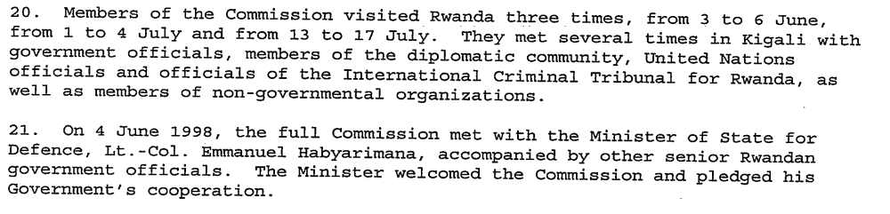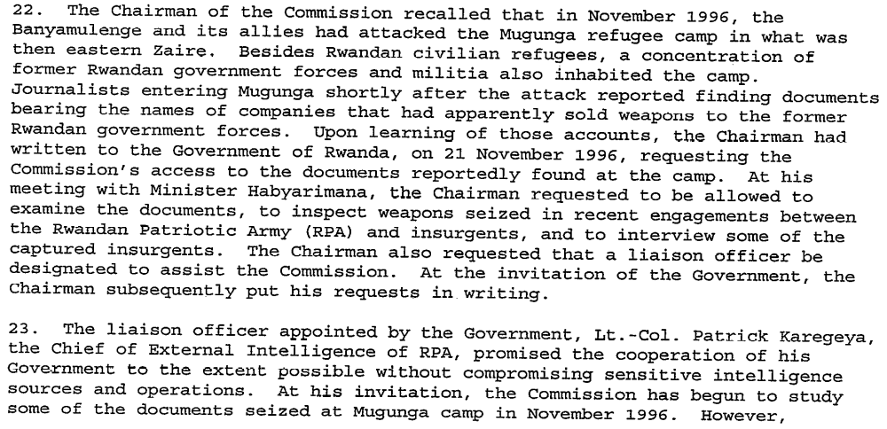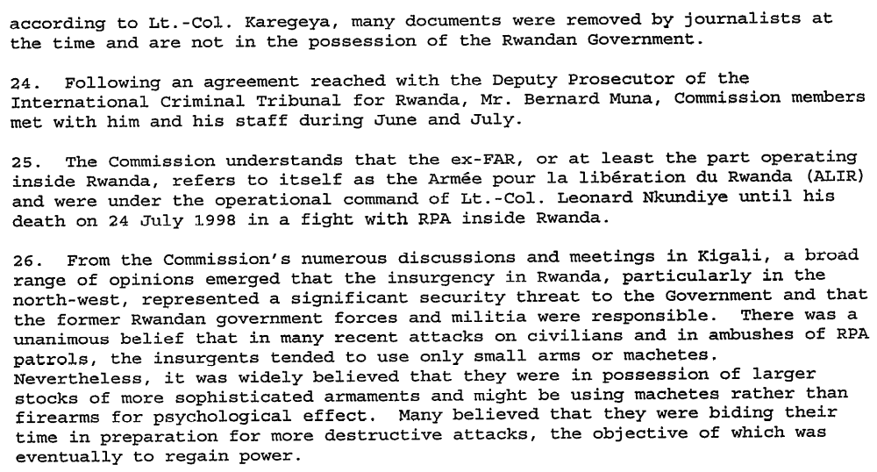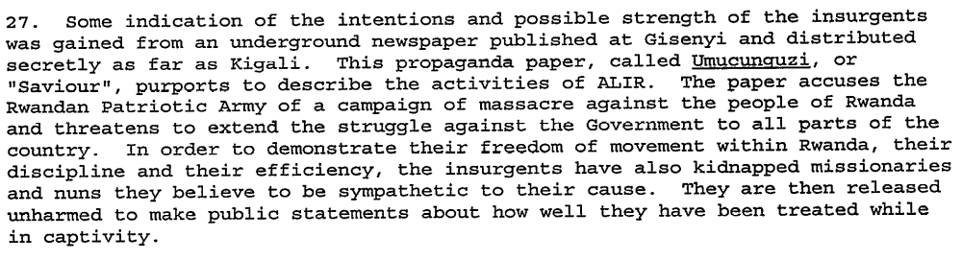(Interim Report of the International Commission of Inquiry (Rwanda), UN Doc. S/1998/777 Annex 1 (19 August 1998), par. 20-27)

Assessment

Short-term compliance
No or marginal compliance (1) | Medium low compliance (2) | Medium high compliance (3) | Full or almost full compliance (4)

Considerations underlying the assessment
Detailed information from Rwanda about the status and armaments of the ex-FAR and Interahamwe forces, both inside and outside Rwanda, and conversations with high government officials.

Medium-term compliance

Description of the addressee(s)’ conduct

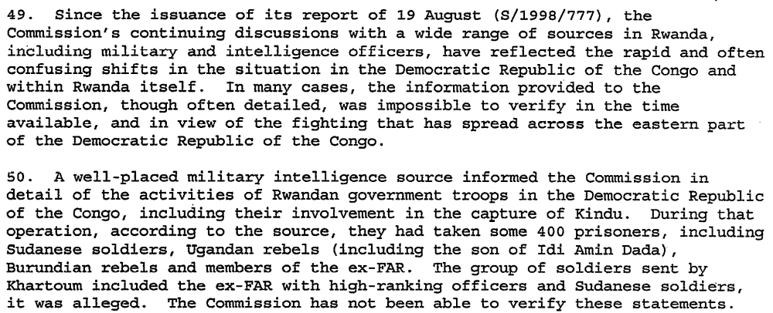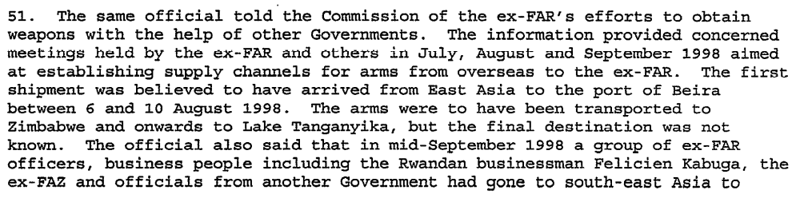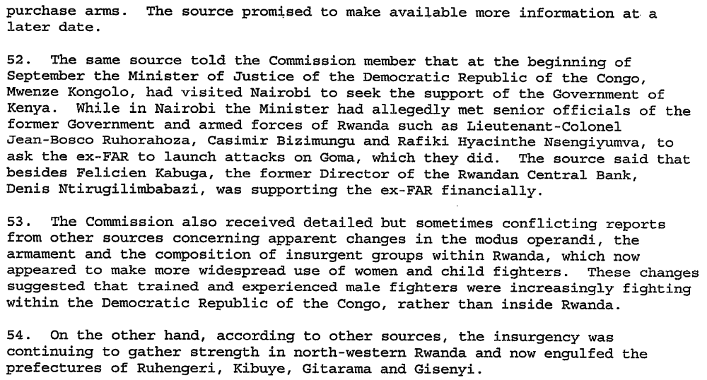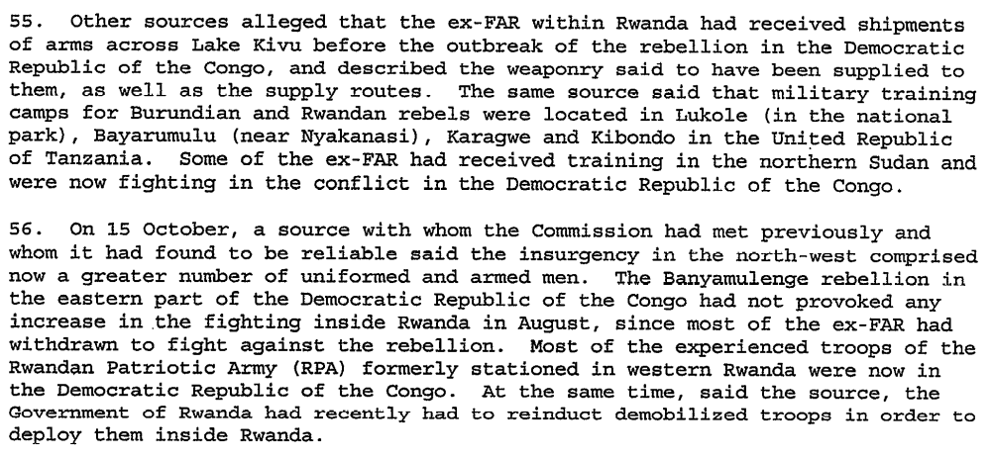

Assessment

Medium-term compliance
No or marginal compliance (1) | Medium low compliance (2) | Medium high compliance (3) | Full or almost full compliance (4)

Considerations underlying the assessment
Detailed information from Rwandan intelligence sources about the status and armaments of the ex-FAR and Interahamwe forces, both inside and outside Rwanda, and conversations with high government officials.

Depth of demand

Assessment

Level of depth of demand
Low depth of demand (1) | Medium depth of demand (2) | High depth of demand (3)

Considerations underlying the assessment

It was in the Government of Rwanda’s best interests to cooperate with the Commission, as any reduction in arms or strength of the ex-FAR and insurgent forces would strengthen the government’s position both inside and outside Rwanda.

Level of confidence about coding decisions

Level of confidence about coding decision
Extremely high | High | Moderate

Comments to IPI (if any)

Civil war in Rwanda

UNSC Resolution: | 1161
Date of adoption: | 9 April 1998
Operative paragraph: | 4
Demand number: | 1161.0411

Carla Winston

Wording of demand
Ensure that their territory is not used as a base for armed groups to launch incursions or attacks against any other State in violation of the Charter of the United Nations and other provisions of international law

List of addressees of the demand
Government of Rwanda

Short-term compliance

Description of the addressee(s)’ conduct

The current round of military conflict is being waged largely between a section of the Congolese Armed Forces and troops still loyal to President Kabila. The Rwandan Army has been accused by the DRC government of backing the insurrection. The new developments come a week after Rwandan troops were officially ordered to leave DRC territory. The Rwandan troops previously played a key role in the war that ousted the late President Mobutu and brought President Kabila to power in May 1997.
…Despite official denials, Rwandans and Ugandans are said to be involved in the Eastern Congo rebellion…The involvement of Rwanda and Uganda in the current military situation in North Kivu complicates the already fragmented and tense situation that has prevailed in the last year.
(“North Kivu – Into the Quagmire? An Overview of the Current Crisis in North Kivu.” International Crisis Group Kivu Report No. 1 (August 1998), page 2.)

In a recent incident, Colonel James Kabare, the former Tutsi chief of staff of the Congo army, was attacked by Congolese junior officers at his residence in Kinshasa and had to be rescued by a core of RPA troops stationed in Kinshasa. On 14 July Colonel Kabare was replaced by a Congolese general, Célestin Kifwa, in a move interpreted by the RPA as intended to drive them out of the DRC. At that point, it became clear that tensions between the two former allies had escalated to a dangerous point. Two weeks later the DRC president ordered the immediate expulsion of all Rwandan troops from Congolese territory, and on 2 August the current military insurrection began.
This chronology suggests that the expulsion of Rwandan troops acted as a catalyst for the insurrection. It could also be interpreted as a panicked last-minute response by the Kabila regime to fear of a secret plan by Rwandan army leaders to take matters into their own hand. The “blitzkrieg” quality of the insurgency across the Kivus has indeed betrayed a level of co-ordination which would not have been likely without Rwandan involvement. … Various testimonies confirm the Rwandan military presence in the Kivus. At least 40 Rwandan army trucks have been seen crossing the border into Eastern Congo.
(“North Kivu – Into the Quagmire? An Overview of the Current Crisis in North Kivu.” International Crisis Group Kivu Report No. 1 (August 1998), page 13.)

Assessment

Short-term compliance
No or marginal compliance (1) | Medium low compliance (2) | Medium high compliance (3) | Full or almost full compliance (4)

Considerations underlying the assessment
Not only were Rwandan troops present in the DRC during the short term, they engaged in an attempt to topple the government when asked to leave, allying themselves with other disaffected parties in the DRC’s eastern provinces.

Medium-term compliance

Description of the addressee(s)’ conduct

The war has not yet produced any winners or losers. After the failed Rwandan attempt at a coup d’état against Kabila in Kinshasa, prevented only by the intervention of Angola and Zimbabwe, the rebel movement now covers almost half of the eastern part of Congo and the north of the country. … The rebels are today divided between those seeking to overthrow Kabila by exercising the military option, who are supported by the Rwandans, and those who would prefer a negotiated settlement and an end to hostilities.
(“Africa’s Seven-Nation War,” International Crisis Group Democratic Republic of Congo Report No. 4 (21 May 1999), page ii.)

The rebel coalition led by Rwanda and Uganda has divided its operational areas into sectors. Rwanda is in charge of a sector that runs from Rutshuru on the border with Uganda to Pepa on the border with Zambia; Uganda is responsible for an area extending from Butembo to Isiro on the border with Sudan, and from Businga in the interior towards Gbadolite. In some cases the sectors are shared, but the absence of a joint general command has led to a lack of coordination on the battlefront. Ugandan troops have been advancing more quickly than Rwandan troops as the opposition is weaker in their sector, composed mainly of Chadian, Congolese and ex-Ugandan government troops. In the Rwandan-led sector, the Rwandan troops and units of the Congolese rebels have been facing a tough challenge from Zimbabwe forces and their allies, which is slowing down their planned advance towards Mbuji-Mayi.
(“Africa’s Seven-Nation War,” International Crisis Group Democratic Republic of Congo Report No. 4 (21 May 1999), page 1.)

Both sides have increased their military build-up since December 1998. The Rwandan troops
and units of Congolese rebels have acquired sophisticated weapons, including missiles capable of bringing down jet fighters. Uganda has imported long-range artillery guns, which they are using to neutralise military units in the northeast. Angola and Zimbabwe had an edge over Uganda and Rwanda in weaponry at the beginning of the war, but now the position is changing and Kabila’s allies acknowledge that the rebel coalition has acquired modern weaponry.
(“Africa’s Seven-Nation War,” International Crisis Group Democratic Republic of Congo Report No. 4 (21 May 1999), page 4.)

In July and August 1999, six Heads of State and over fifty rebels leaders signed a
ceasefire in Lusaka, Zambia, to end the fighting in the Democratic Republic of the
Congo (DRC) – Africa’s first continental scale war. Tragically, the fighting never
stopped. …
In the midst of the Lusaka talks, the situation turned critical for Kabila and his government. On 15 June 1999, RPA forces crossed the Sankuru River and captured the Kasai Oriental town of Lusambo.1 The river formed the last natural obstacle in front of province’s diamond-rich capital of Mbuji Mayi. The overwhelmed FAC defenders fled, leaving behind their Zimbabwean and Namibian allies.2 The RPA pressed on towards Kananga.3 By early July they had enlarged their bridgehead with the capture of the towns of Pania-Mutuombo and Dimbelenge, 75 km short of Mbuji Mayi.
In the east other RPA units simultaneously advanced from the direction of the north Katanga town of Kabalo. Heavy fighting was reported in Eshimba, east of Kabinda on May 22.4 A week later the RPA had reached Kabinda, some 120 km to the east of Mbuji-Mayi. “The noose is obviously tightening,” reported Radio France Internationale.5 Kabila was under serious pressure and appeared on the verge of losing the war had a ceasefire not been reached.
(“Scramble for the Congo: Anatomy of an Ugly War,” International Crisis Group Africa Report no. 26 (20 December 2000), pp. 2-3.)

In March [2000] heavy fighting erupted in Kasai Occidental. A Rwandan offensive ostensibly launched in response to FAC provocations, captured Idumbe, Mashala, and Demba. In the east Kabinda was also reportedly attacked.18 These advances brought the RPA and RCD to within several kilometres of the Katanga railroad that connects Kinshasa with the southern province via the Kasai River port of Ilebo.19
(“Scramble for the Congo: Anatomy of an Ugly War,” International Crisis Group Africa Report no. 26 (20 December 2000), p. 13.)

Rwanda has sought to recruit the Congolese Hutus and organise them in local defence forces with the argument that there exists a common interest in peace for all the Banyarwanda. Early on during the RPA occupation, ‘promising’ individuals were transported to Rwanda for several months of political-military indoctrination.54 Once the training completed, these students returned to their homes where they were tasked to spread anti-Interahamwe propaganda.55 Similar three-month political-military courses are now conducted in the DRC for local defence forces.
When the RPA sets out to pacify a region, it begins by occupying it militarily. Then it makes contact with all the local authorities (such as chefs de quartier, Mwamis and priests) in order to mobilise support for the formation of a local defence force training camp. Other than medicine and instructors, the local population must supply everything, including food and students. At one point earlier this year in North Kivu, there were six training camps in operation simultaneously. In North Kivu alone the RCD claims to have 10,000 local defence forces members. In South Kivu these camps have reportedly been organised in Kiziba, Kavumu, Katana, and Kalemie.56
(“Scramble for the Congo: Anatomy of an Ugly War,” International Crisis Group Africa Report no. 26 (20 December 2000), p. 16.)

Assessment

Medium-term compliance
No or marginal compliance (1) | Medium low compliance (2) | Medium high compliance (3) | Full or almost full compliance (4)

Considerations underlying the assessment
Not only were Rwandan troops present in the DRC, they engaged in an attempt to topple the government, allied with and trained local DRC groups and defence forces, and conducted numerous military operations against several parties, both before and after the Lusaka Agreement of 1999.

Depth of demand

Assessment

Level of depth of demand
Low depth of demand (1) | Medium depth of demand (2) | High depth of demand (3)

Considerations underlying the assessment
Rwanda’s concerns in the DRC were, at least in the beginning, related to the presence of ex-FAR and Interahamwe forces in Eastern Zaire/Congo. Since these groups wished to re-enter Rwanda to overthrow the government, there was no real prospect that these groups would then use Rwanda as a base to launch attacks against anyone else. There was no other group present in Rwanda planning to launch incursions against other countries, so there was no risk for Rwanda in preventing such an occurrence. Instead, Rwanda chose to launch an attack against another country itself.

Level of confidence about coding decisions

Level of confidence about coding decision
Extremely high | High | Moderate

Comments to IPI (if any)

Civil war in Rwanda

UNSC Resolution: | 1329
Date of adoption: | 5 December 2000
Operative paragraph: | 5
Demand number: | 1329.0511

Carla Winston

Wording of demand
Cooperate fully with the International Tribunals and their organs in accordance with the obligations under resolutions 827 (1993) and 955 (1994) and the Statutes of the International Tribunals

List of addressees of the demand
Government of Rwanda

Short-term compliance

Description of the addressee(s)’ conduct
In early 2001, the Rwandese Patriotic Front (RPF)-led government agreed to cooperate with the ICTR's investigation into crimes against humanity allegedly committed by members of the RPF in 1994.
(2002 Annual Report for Rwanda. Amnesty International. http://www.amnestyusa.org/annualreport.php?id=36A08C05CF870D3D80256BAE0056D39E&c=RWA )

Assessment

Short-term compliance
No or marginal compliance (1) | Medium low compliance (2) | Medium high compliance (3) | Full or almost full compliance (4)

Considerations underlying the assessment
The agreement to cooperate with the investigation into RPF crimes was a big deal, even though the investigation would not necessarily proceed quickly in the short term. The easing of relations between the ICTR and the Government of Rwanda related to this agreement also meant greater access for ICTR officials and investigators for cases not related to the RPF investigation.

Medium-term compliance

Description of the addressee(s)’ conduct

At the same time, not one case has been brought after eight years against members of the Rwandan Patriotic Army for grave violations of human rights allegedly committed on the territory of Rwanda in 1994. There has been no cooperation at all from the Rwandan authorities on these matters. The reluctance and refusal of the current government in Kigali in relation to these cases is the reason for the unprecedented crisis that has existed since June 2002 between the ICTR and Rwanda. The Rwandan government must honour its obligations to cooperate with the Tribunal and stop all forms of obstruction – such as the restriction of access to witnesses living in Rwanda.
In future, the tension between the Tribunal’s need for cooperation with the government of Rwanda and the independence that is essential to its mandate is likely to worsen. Passive, defensive or short-sighted responses, as have been made recently, will only weaken the Tribunal and make it a prisoner of its own contradictions and of the interests of the Rwandan government.
(The International Criminal Tribunal for Rwanda: The Countdown. ICG Africa Report No. 50 (1 August 2002), Executive Summary.)

In June (2002), the Rwandese government changed its travel regulations for witnesses giving evidence at the ICTR, allegedly in order to delay trials. Two ongoing trials were adjourned several times owing to the lack of witnesses. In August, the President of the ICTR wrote to the UN Security Council accusing the Rwandese government of failing to cooperate with the Tribunal. The government in turn accused the ICTR of "mismanagement, incompetence and corruption". The government further stated that it would not cooperate with the ICTR prosecutor to investigate alleged war crimes committed by Rwandan Patriotic Army (RPA) members during the genocide and the armed conflict that brought the current government to power.
(2003 Annual Report for Rwanda. Amnesty International. http://www.amnestyusa.org/annualreport.php?id=57AB91BA5401BB1F80256D2400379406&c=RWA)

The Tribunal is also dependent on the Rwandese state because of the latter's control of Rwandese witnesses and crime sites. The Rwandese government voted against the Tribunal's establishment and has actively campaigned against successive ICTR Chief Prosecutors. The Rwandese government has also denied the Tribunal's investigative units access to Rwanda, sometimes by refusing to guarantee their safety. It has also blocked the prosecution's access to witnesses during trials. Three trials were adjourned on several occasions in 2002 due to the lack of witnesses caused by the government's change of travel regulations, which followed an announcement by ICTR Prosecutor Carla Del Ponte regarding investigations against RPA soldiers,(4) and the government's influence over genocide groups that urged witnesses not to testify before the Tribunal.
(Rwanda: The Enduring Legacy of Genocide and War. Amnesty International, April 5, 2004. http://www.amnestyusa.org/document.php?id=D255BF899579F34A80256E67005A4F1C&lang=e )

Assessment

Medium-term compliance
No or marginal compliance (1) | Medium low compliance (2) | Medium high compliance (3) | Full or almost full compliance (4)

Considerations underlying the assessment
Increasing intransigence by the Government of Rwanda in response to the ICTR’s initiative to investigate possible atrocities committed by the forces of the RPF.

Depth of demand

Assessment

Level of depth of demand
Low depth of demand (1) | Medium depth of demand (2) | High depth of demand (3)

Considerations underlying the assessment
Full compliance would have meant possibly surrendering current high government officials for prosecution by the ICTR, as many of them were RPF commanders suspected of having known about or directed abuses during the period within the ICTR’s jurisdiction.

Level of confidence about coding decisions

Level of confidence about coding decision
Extremely high | High | Moderate

Comments to IPI (if any)

Civil war in Rwanda

UNSC Resolution: | 1431
Date of adoption: | 14 August 2002
Operative paragraph: | 3
Demand number: | 1431.0311

Carla Winston

Wording of demand

Cooperate fully with the International Tribunal for Rwanda and its organs in accordance with their obligations under resolution 955 (1994) and the Statute of the International Tribunal for Rwanda

List of addressees of the demand

Government of Rwanda

Short-term compliance

Description of the addressee(s)’ conduct

In recent weeks, the Rwandan government has increased its cooperation to the extent of permitting some witnesses to travel to Arusha to testify. In an apparently related development, the prosecutor has in fact suspended investigation of RPA crimes. If the partial reduction in obstacles to the travel of witnesses results from an explicit or implicit quid pro quo, these developments represent a serious infringement of the independence of the prosecutor.
The Rwandan government has also submitted to the Council its own complaints about the operations of the ICTR. Certainly there are aspects of ICTR operations that could and should be improved, but a government cannot be permitted to take failings in the operation of a U.N. institution as an excuse for not fulfilling Chapter VII obligations to cooperate with that institution.
(Human Rights Watch, “Action Urged regarding non-cooperation with ICTR and ICTY.” Letter to Security Council Members, October 25, 2002. http://www.hrw.org/en/news/2002/10/25/action-urged-regarding-non-cooperation-ictr-and-icty )

There is one further issue. A year ago, the Rwandan government provoked a serious crisis in its difficult relationship with the court when it prevented the travel of witnesses whose presence was required for cases to proceed because it objected to the prosecutor’s inquiries into war crimes presumed to have been committed by the RPA in 1994. The formal suspension of Carla del Ponte’s investigations in September 2002 and the establishment of a U.S.-sponsored deal between the prosecutor’s office and the Rwandan authorities seemed to have improved the situation. At a tripartite meeting in Washington in May 2003 an agreement was reached in principle whereby Kigali would take responsibility for the trials, and the ICTR would only intervene if Rwanda was unable to carry them out satisfactorily. However, the ejection of Carla del Ponte from the prosecutor’s seat following the Security Council decision to separate the ICTR and the International Criminal Tribunal for the former Yugoslavia (ICTY) means that there will probably never be a trial of the RPA in Arusha. (International Tribunal for Rwanda: The Time for Pragmatism. ICG Africa Report No. 69 (26 September 2003), Executive Summary.)

Assessment

Short-term compliance
No or marginal compliance (1) | Medium low compliance (2) | Medium high compliance (3) | Full or almost full compliance (4)

Considerations underlying the assessment

The Government of Rwanda made the work of the Tribunal very slow, and hampered its ability to conduct trials, by denying travel visas and generally refusing to guarantee security of ICTR officials and witnesses. This was linked to dissatisfaction with the ICTR’s decision to begin prosecuting persons formerly of the RPF armed forces for abuses committed in 1994. A temporary easing of restrictions was only achieved when the Prosecutor shelved RPF investigations, which significantly hampered the ability of the ICTR to fully accomplish its mandate.

Medium-term compliance

Description of the addressee(s)’ conduct

Rwandan government officials have tried to make arrangements with the prosecutor's office to end or at least to minimize prosecutions of RPA soldiers in return for providing greater cooperation in prosecuting cases of genocide. The last such attempt took place in Washington, D.C. in mid-May 2003, facilitated by U.S. government officials. The effort failed and the Rwandan government stepped up its campaign to remove the current prosecutor. (Human Rights Watch, “Rwanda and the Security Council: Changing the International Tribunal,” Letter to Council Members on the International Criminal Tribunal for Rwanda, August 1, 2003. http://www.hrw.org/en/news/2003/08/01/rwanda-and-security-council-changing-international-tribunal )

Rwanda took months before approving the transfer of detainees in government custody to testify in Arusha and has not yet complied with all ICTR requests for such transfers. In addition, the authorities in Kigali have not yet provided large numbers of documents necessary for trials, some of them under way at the present time. (Human Rights Watch, “Deadlines for the Tribunals for the Former Yugoslavia and Rwanda must be flexible.” A Letter to the U.N. Security Council, June 4, 2004. http://www.hrw.org/en/news/2004/06/24/deadlines-tribunals-former-yugoslavia-and-rwanda-must-be-flexible )

Assessment

Medium-term compliance
No or marginal compliance (1) | Medium low compliance (2) | Medium high compliance (3) | Full or almost full compliance (4)

Considerations underlying the assessment

The Government of Rwanda made the work of the Tribunal very slow, and hampered its ability to conduct trials, by denying travel visas and generally refusing to guarantee security of ICTR officials and witnesses. This was linked to dissatisfaction with the ICTR’s decision to begin prosecuting persons formerly of the RPF armed forces for abuses committed in 1994. A temporary easing of restrictions was only achieved when the Prosecutor shelved RPF investigations, which significantly hampered the ability of the ICTR to fully accomplish its mandate, and in fact did not really improve the speed of other trials, since Rwanda was slow to comply with requests anyway.

Depth of demand

Assessment

Level of depth of demand
Low depth of demand (1) | Medium depth of demand (2) | High depth of demand (3)

Considerations underlying the assessment

Full compliance would have meant possibly surrendering current high government officials for prosecution by the ICTR, as many of them were RPF commanders suspected of having known about or directed abuses during the period within the ICTR’s jurisdiction.

Level of confidence about coding decisions

Level of confidence about coding decision
Extremely high | High | Moderate

Comments to IPI (if any)

